**Initial Installation and Setup**

1. **Installing Python**

* Go to [www.python.org](http://www.python.org)

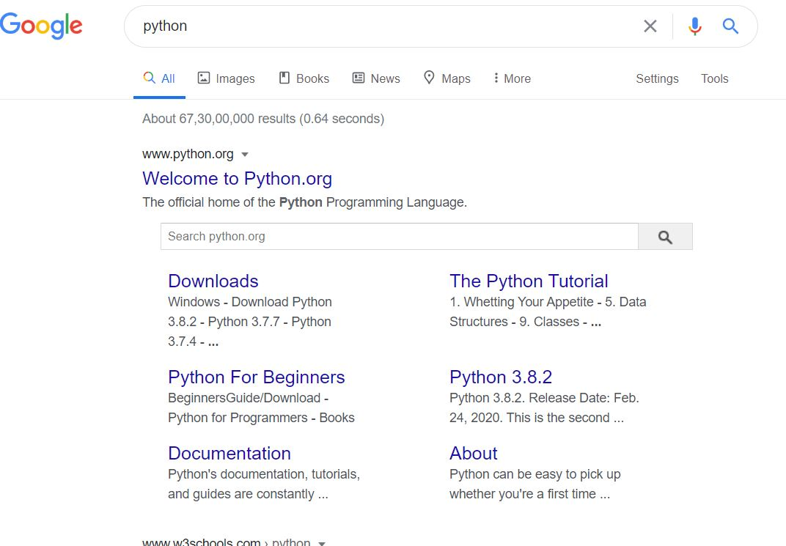

* 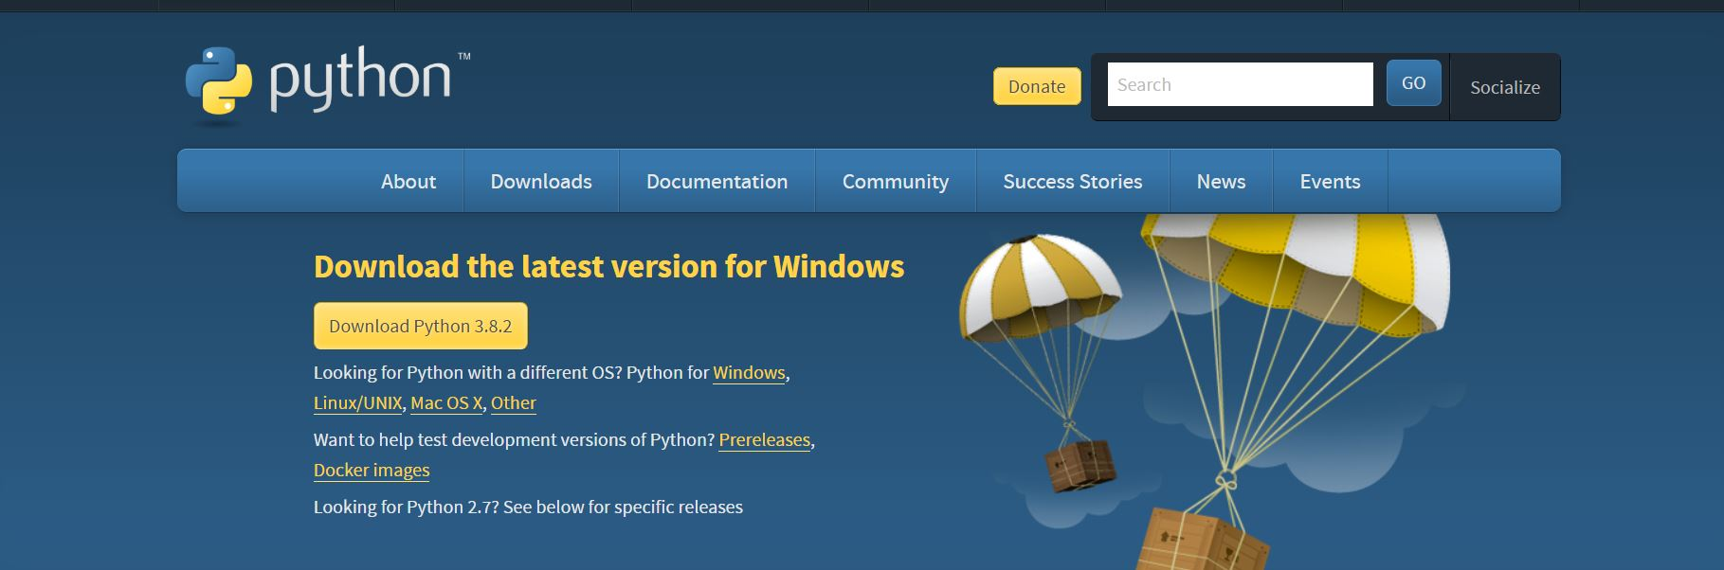Scroll down and click on download
* And download python
* Now go to python setup and install python

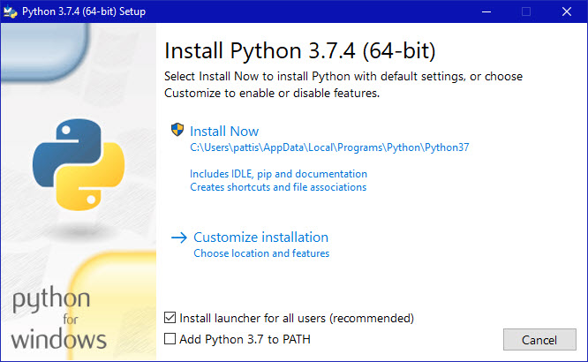

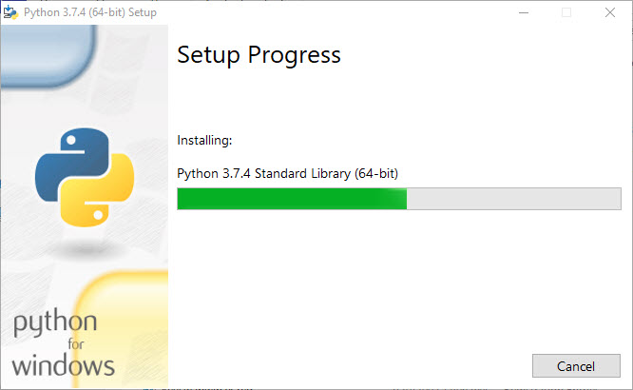

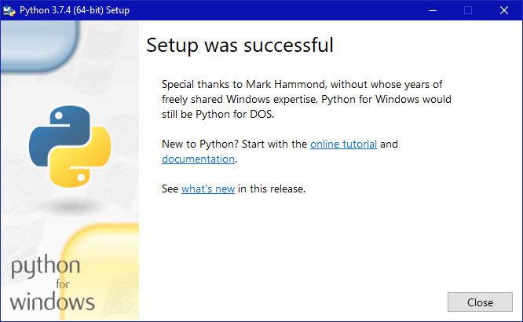

**Installing Anaconda and Jupyter notebook**

Go to anaconda and download anaconda setup

<https://www.anaconda.com/download/#windows>

after downloading install anaconda

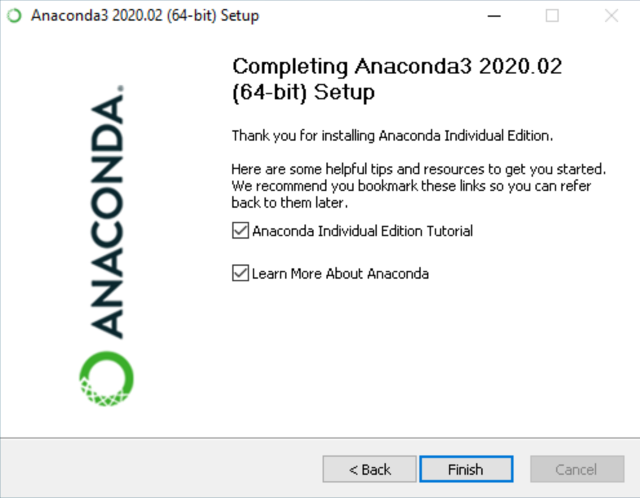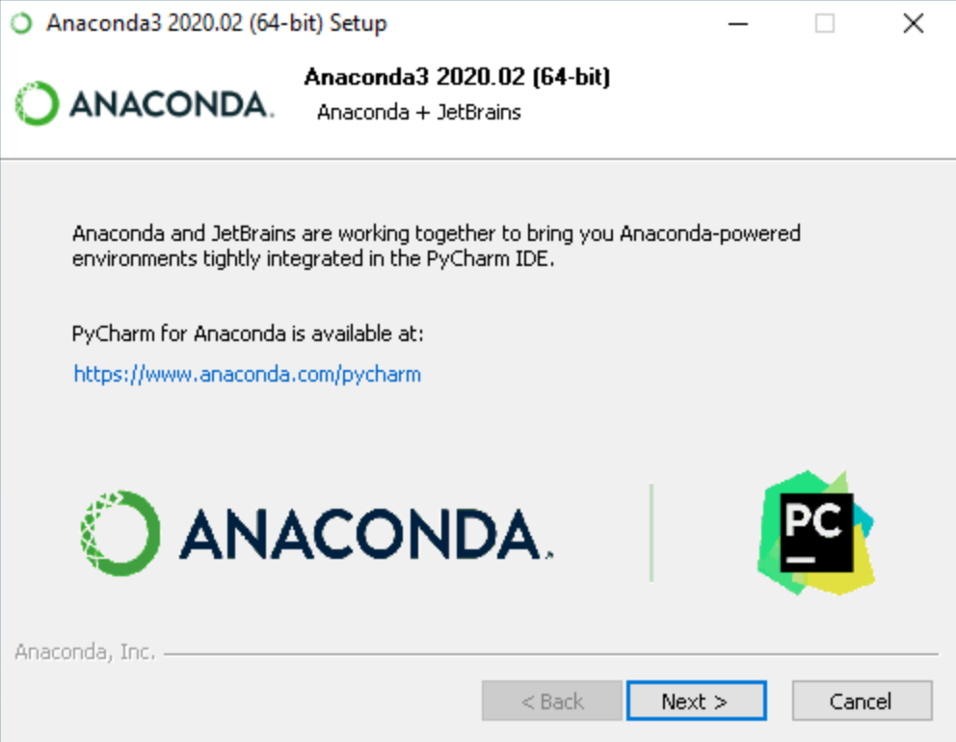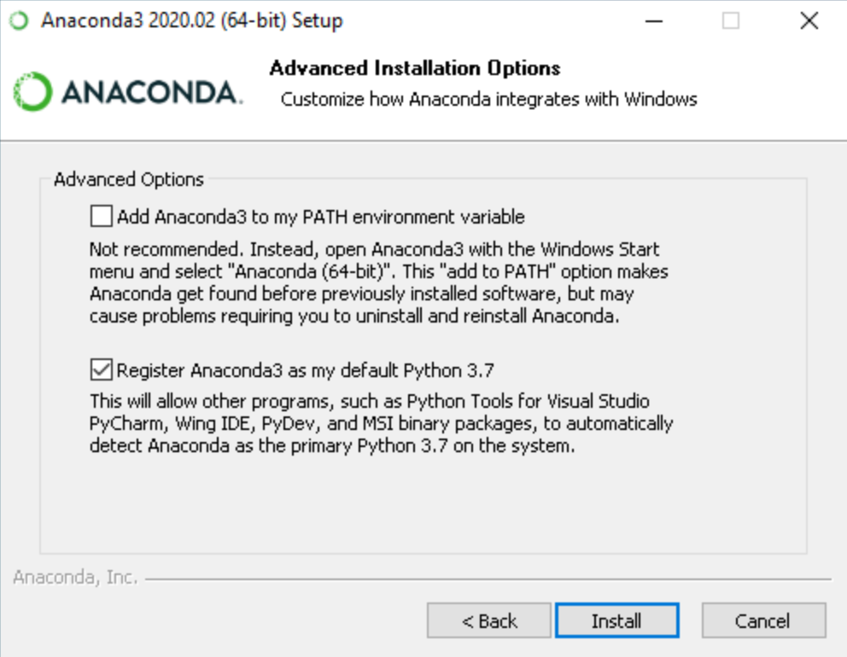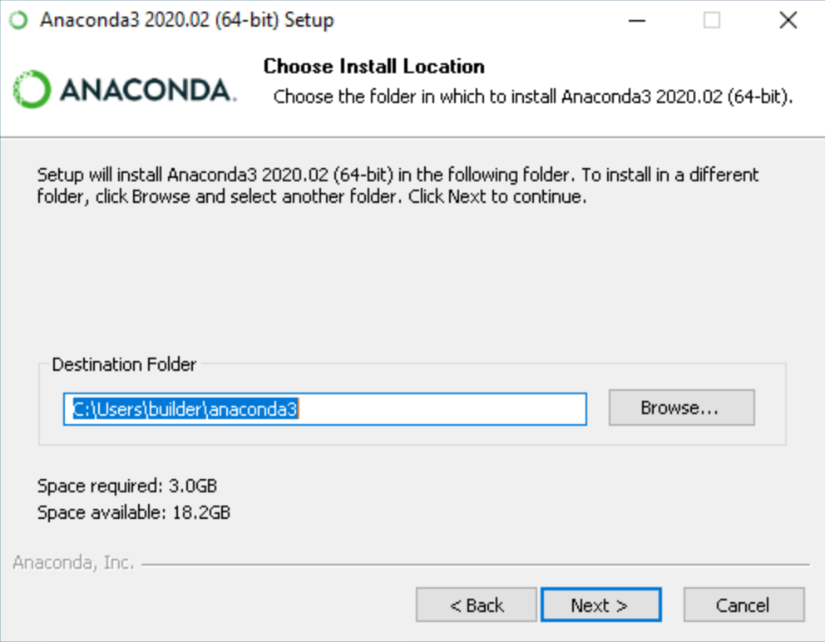

**Installing Jupyter notebook**

1. 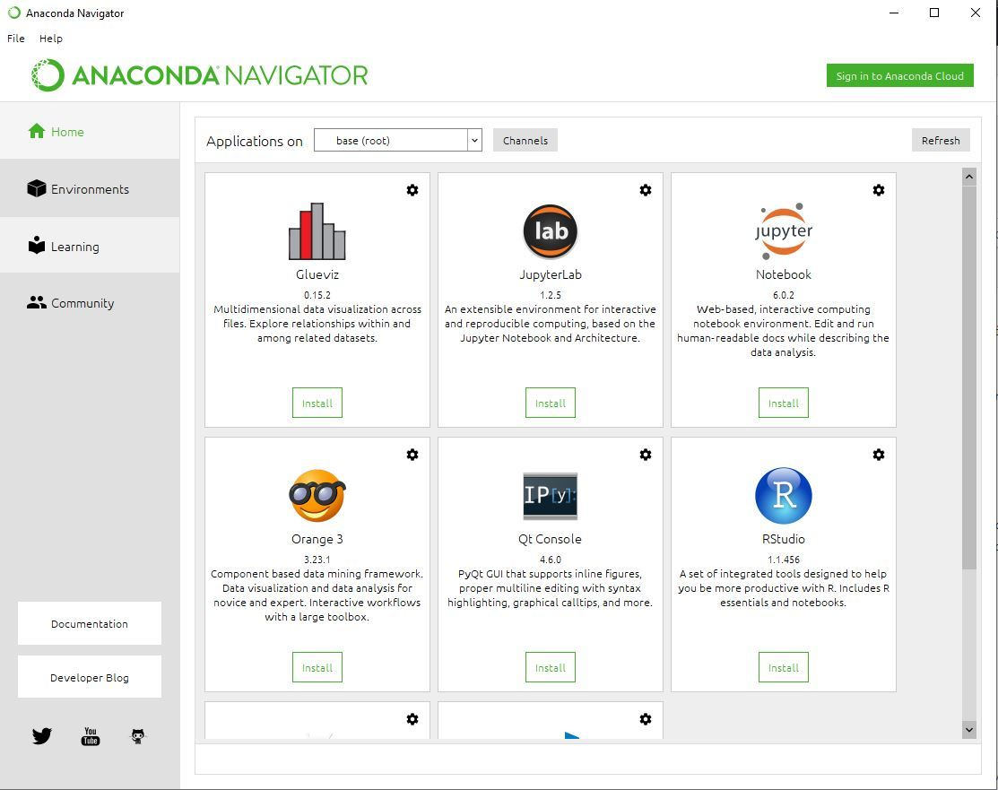**Open anaconda**
2. 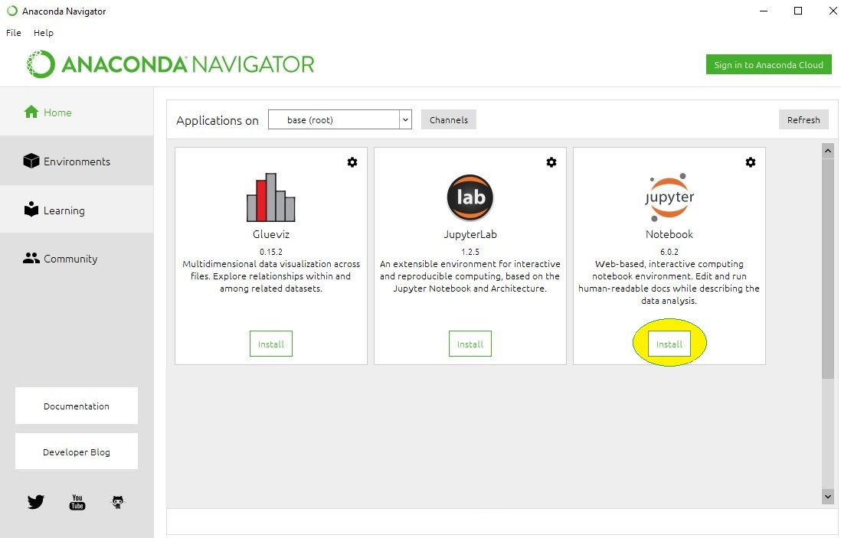Click on install Jupiter notebook
3. 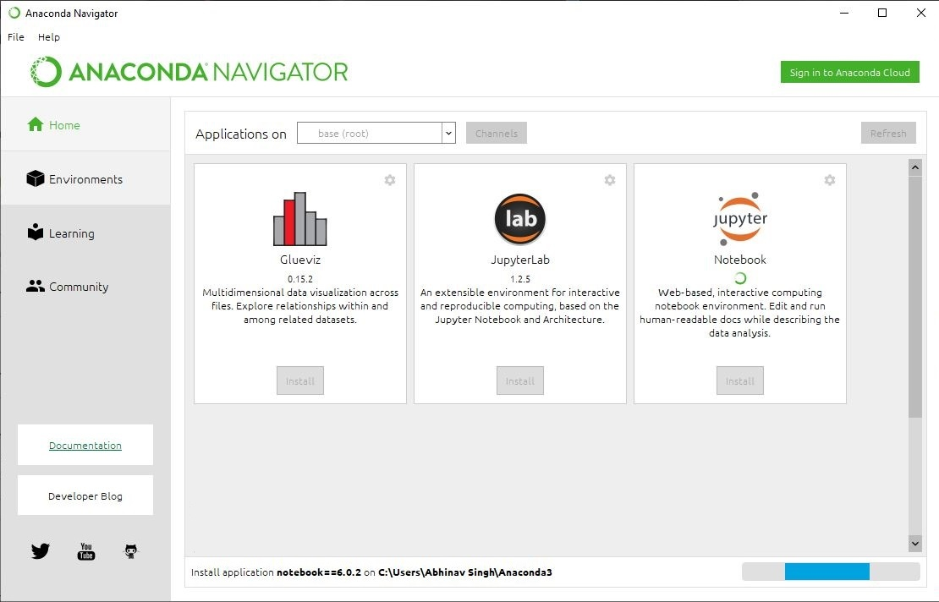Give path for installation
4. 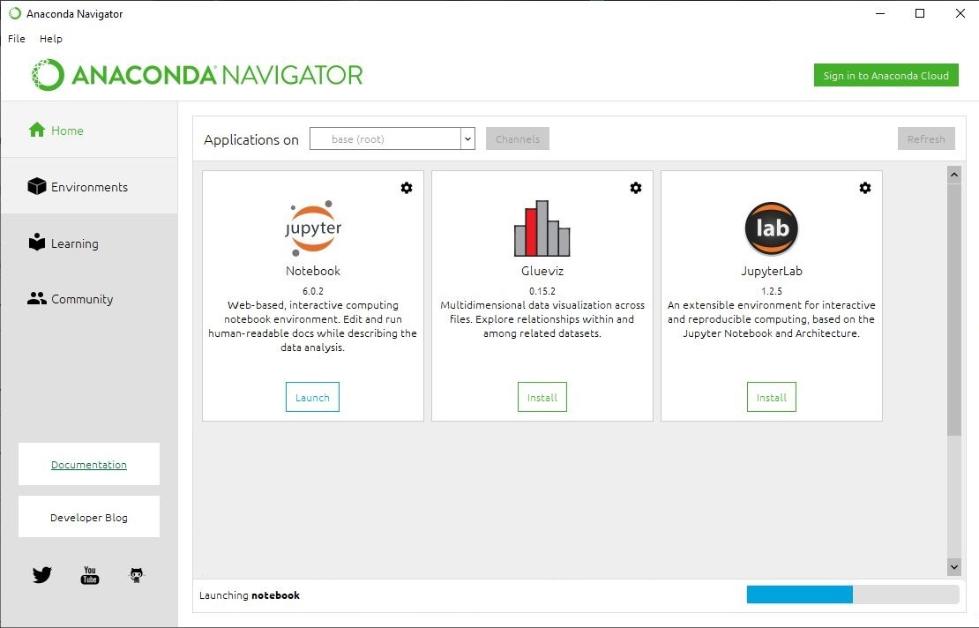Launch Jupyter notebook